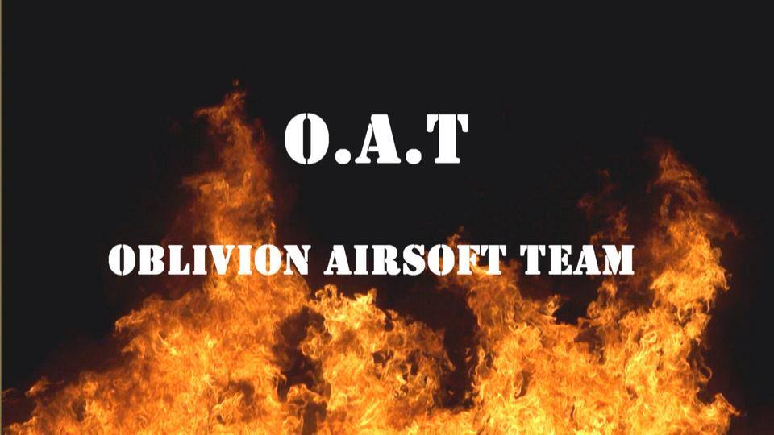

Name:
Date of Birth:
Gender:
Location (Address, Town, State):
Email:
Preferred phone number:
Do you use Instagram, Facebook, Youtube, etc? Yes – No
Driver’s License? Yes – No
Callsign (if you have one):
How long have you been involved in playing airsoft for?
What is the playing style like that you normally play in (ex: CQB skirmishes, local small Ops, MilSim, etc):
List the fields you normally play at/ have played at:

Have you been affiliated with any airsoft team(s) before? Yes – No
If so, which team(s)
Why did you leave?:
What role(s) do you feel you could fill on the team? (ex: SAW, Rifleman, Grenadier, etc.):
Read team requirements. List the one’s you meet and do not meet:

1. FOOTWEAR - Must have boots. Sneakers are okay for indoors but boots are required for outdoors, MilSim, and ops. Reason is because sneakers don't hold up as well as boots do with extensive use on them in the field.

2. WEAPON - Must own your own gun clearly, and own mags. Mid caps are necessary for MilSim, as well as Ops.

3. GEAR - Must have either a tactical vest, plate carrier, belt setup or chest rig. Reason for this is so other teammates don't have to carry extra mags and certain tools around for you.

4. EXPERIENCE - Must have experience in the sport of airsoft, and/or real world.

5. FACE PROTECTION - Must have proper eye protection. Full seal goggles. This for YOUR safety. We don't want you to lose your sight due to a bb. If under 18, lower face protection of some sort is needed.

6. AGE - It is recommended that you are 15 years of age or older.

7. UNIFORM - M81 Woodland is team uniform for green-side (most games we attend), DCU is tan-side uniform. At CQB and skirmishes, anything goes. Also, any form of green headgear is required.

8. COMMUNICATION - COMMS (radios) are required. This should be self explanatory. Baofeng, or any radio of that sort is strongly recommended.

9. LOCATION - Massachusetts area is where we are based, that area is recommended.

10. ATTENDANCE - Must able, ready, and willing to be an active member and to attend and to participate in a moderate to serious amount of team days and events.

11. FUNDS - No charge to join at all. Although we will ask for every member to pitch in money when the time comes for a team affiliated want/need.

12. LOYALTY - Must be loyal to the team and obey the rules of airsoft. This is a serious field, disobedience of rules of the sport can lead to a boot from the team.

13. FIREARM SAFETY - Must know and understand proper firearm safety. Period. Look up what that is if you have no idea.

IF YOU DO NOT HAVE ONE OR SOME OF THESE, CONTACT US
(If booted from team, or member leaves, turn in patch to CO, as well as shirt. Your money will be refunded if item was purchased.)

